<https://bit.ly/3o237ZA> <https://bit.ly/3z8qWpi>

<https://bit.ly/3IHKpjM>

email@emailaddress.com

111-222-3333

<https://bit.ly/3APwx4V>

This breakthrough rental ERP system is designed from the ground up for the rental industry. Infor® SyteLine Equipment Rental & Service ERP is a fully functional, end-to-end system, delivered in a modern, simple user interface. Employing cutting edge technology, it’s available in cloud, on-premise or hosted.

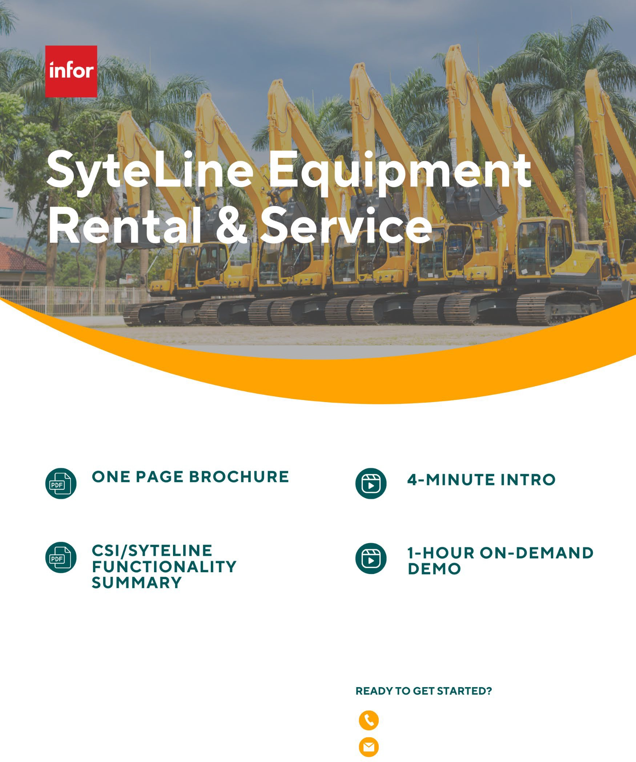

Add your logo